ELCT Press Release
Date: June 26, 2013
Press release No. 008/06/2013
The Way ELCT Celebrated her 50th Anniversary
By Elizabeth Lobulu
The Evangelical Lutheran Church in Tanzania (ELCT) brought the Lutheran world to Tanzania when it celebrated the climax of her 50th Anniversary at Tumaini University Makumira on June 21 to 23, this year. Foreign guests came from across the globe: from Africa, Europe, America and Canada. Overall at least 1,500 people attended the service.
Kilimanjaro International Airport became the point of entry for many guests
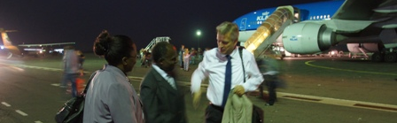
The ELCT Secetary General, Mr Brighton Killewa, receives Rev Martin Junge, LWF General Secretary (R) when he arrived at KIA on 21 June 2013. On the left is LWF Area Secretary for Africa, Rev Dr Eliesh Mungure.
The Church shows her commitment to conserve God’s creation
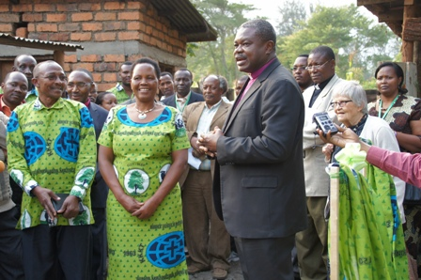  The ELCT Presiding Bishop, Dr Alex Malasusa, handing over a biogas digester to its beneficiaries Mr Joshua and Mrs Christina Mwanga at Makumira June 21. | 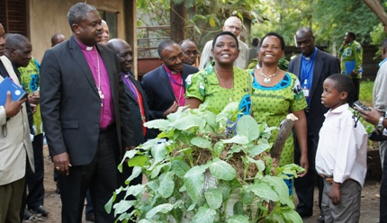  Patricia Mwaikenda (3rd R), Coordinator of Sustainable Livelihood and Environment Programme briefs Bishop Malasusa who inaugurated the 800th biogas plant built with support of ELCT.

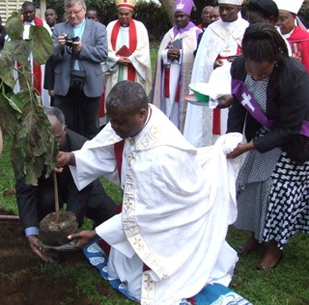  The ELCT Presiding Bishop who is also the Vice-President of the LWF (Africa Region) plants a tree at Makumira. | 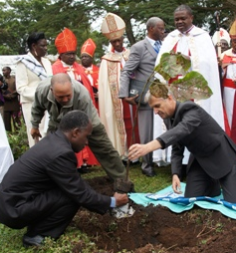  The LWF General Secretary (R)  Rev. Martin Junge planted a tree on behalf of the LWF global communion. | 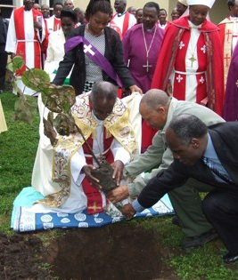  Retired ELCT Presiding Bishop  Dr Samson Mushemba plants a tree.
The Church had organized an exhibition
On 21 June an exhibition to show case the work and life of the church in and outside the country was organized at Makumira.
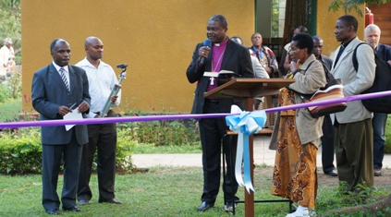
The Presiding Bishop opening the exhibition. Left is the Secretary General of ELCT
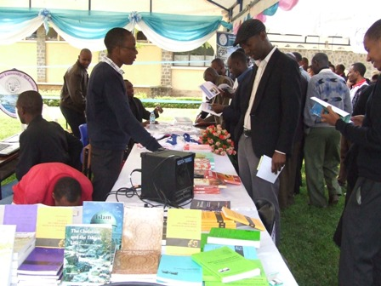  Tumaini University Makumira tent. | 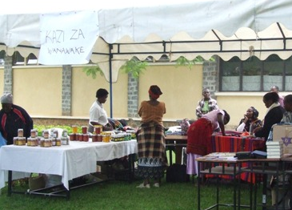  ELCT Meru Diocese - Women Department tent.

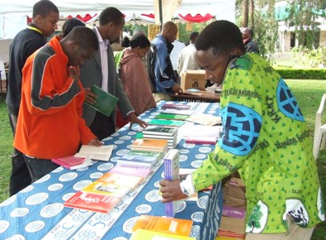  ELCT literature exhibition area. | 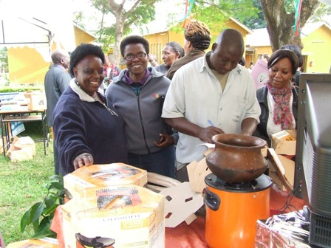  Improved cooking stove on display as part of PHC pavilion.

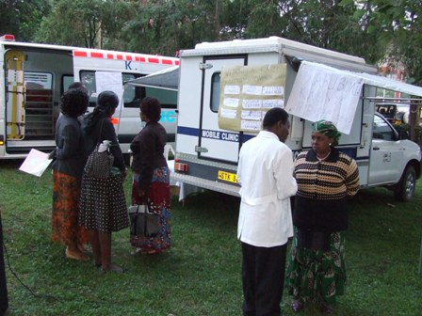  The KCMC Mobile Clinic and a state of the art ambulance. | 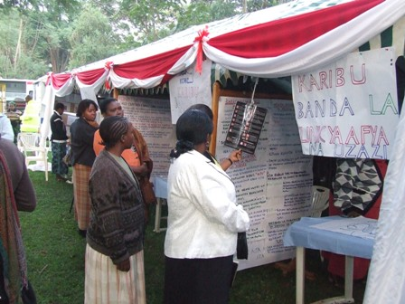  An exhibition area for KCMC.
A workshop was held on 22 June
About 500 participants attended a workshop comprising local and foreign church leaders, academicians, students ELCT staff and members. They met for a one-day consultation to assess the strides made by the Church in the past 50 years and paved a way forward for the future. The debate and the church service on 23 June aired live on Radio Voice of the Gospel (Sauti ya Injili in Kiswahili) as well as Upendo FM in the ELCT Eastern and Coastal Diocese and Furaha FM in Iringa Diocese.

The presentations were on 5 topics namely: The Impact of Globalization on the Church in Africa by Prof. Wilfred Mlay; The Importance of Teaching the Foundation of Faith and Professional Ethics in Higher Learning Institutions and its contribution in building an ethical nation by Prof. Festo Bahendwa; New Areas of Mission in 50 years to come (New strategies of opening new frontiers, facing the challenges of fast growing cities and the role of Evangelism and Diaconate, Integrity of Creation and Gender Issues)by Bishop Dr Benson Bagonza; Facing the Challenges of Charismatic Movement and Pentecostalism (Healing and Miracles) by Rev. Dr Msafiri J. Mbilu and The Role of African Evangelists in the Western Hemisphere by Rev. Alphaeus Shayo.
An archive to be built at Tumaini University Makumira (TUMA).
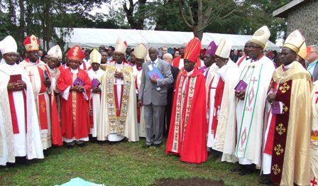  Bishops assembled at a place where 3 trees were planted at Tumaini University Makumira (TUMA) on Sunday 23 June. | 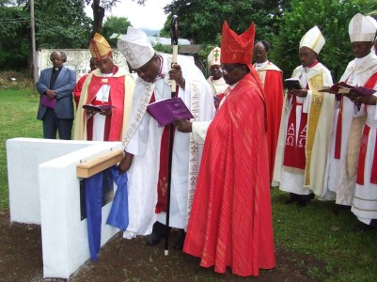  The Presiding Bishop Dr  Malasusa assisted by Bishop Dr Bagonza to unveiled a plaque for the foundation stone of the proposed archive at TUMA.
A Procession for the Church Service included pastors, congregants and choir groups.
A colourful five-hour Sunday Service on June 23 brought together a mass choir comprising 320 people.
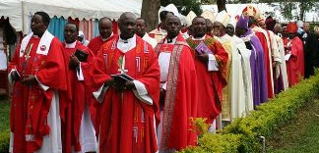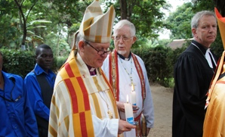

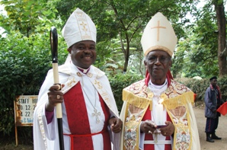  It was all smiles for current ELCT incumbent Presiding Bishop Dr Alex Malasusa (L) and the former Presiding Bishop Dr Samson Mushemba. (Photo by Heidi Martinussen/ LWF) | 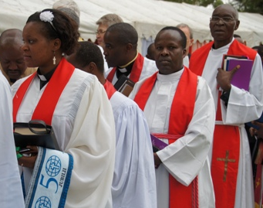  The procession

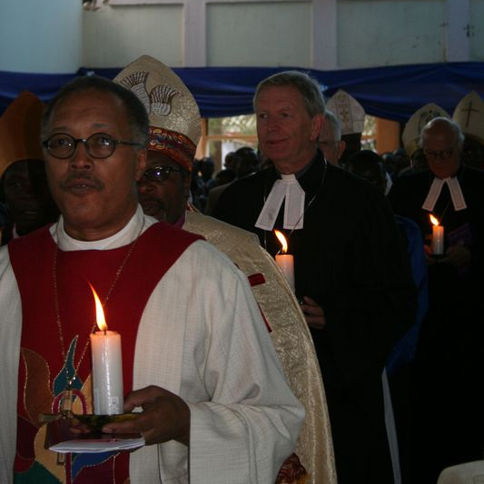 | 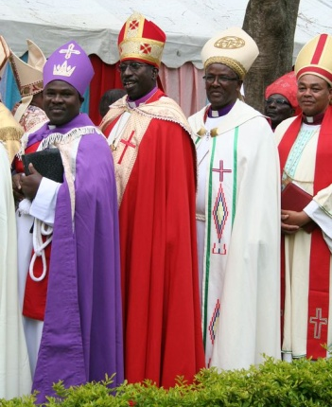 | 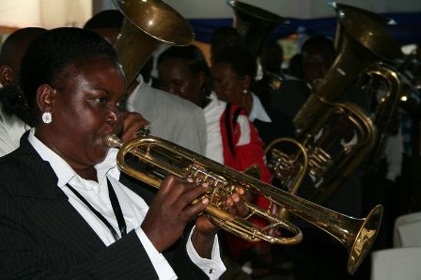

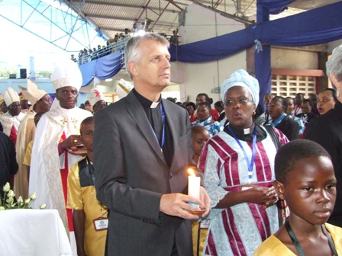 | 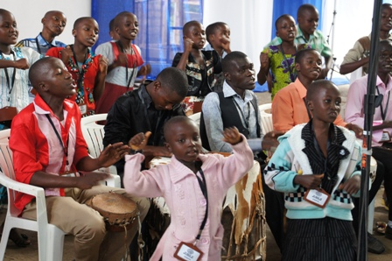  The children choir from the ELCT Konde Diocese.
The Climax of the ELCT jubilee on 23 June 2013 in pictures
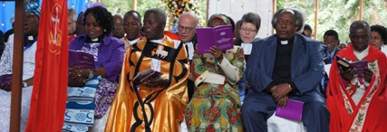 | 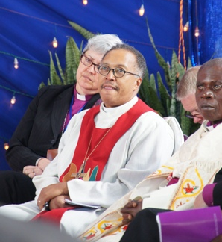

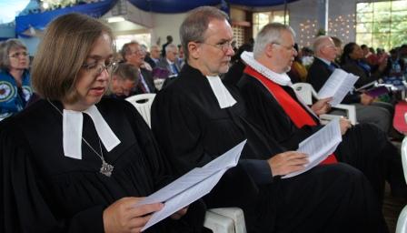 | 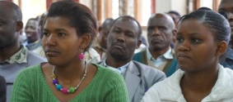

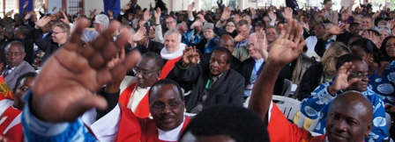
Members of the congregation during the service
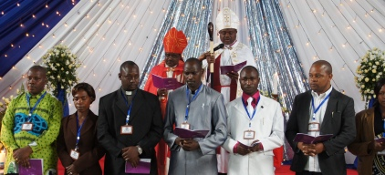
For the first time in the history of the Church, the Youth Committee was inaugurated on June 23, 2013.
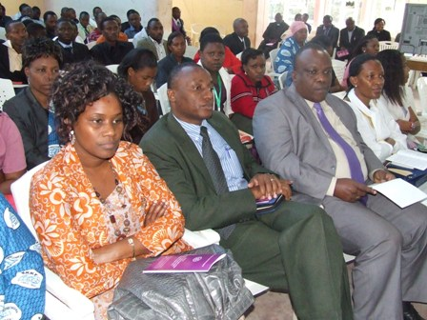 | 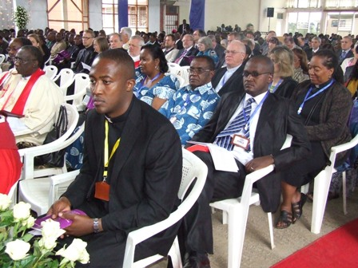

The Mass Choir comprised 320 people
The choir groups came together for rehearsal and music gala on June 21 on the eve of the climax.
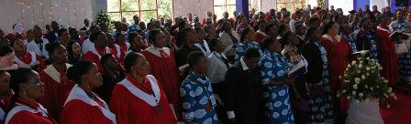
Faces at the ELCT jubilee climax
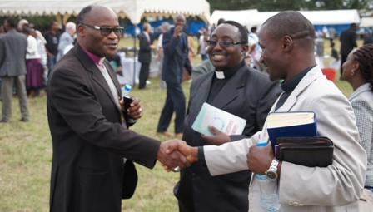 | 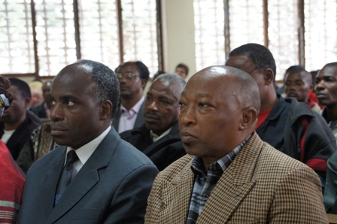 | 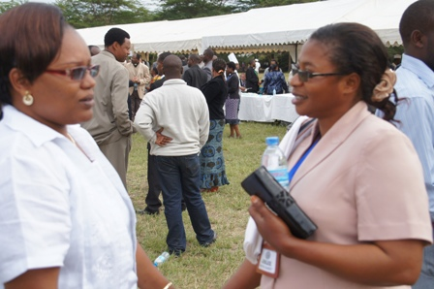

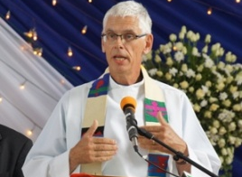 | 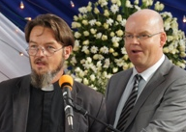 | 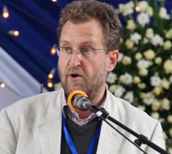 | 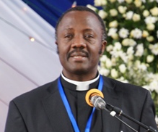 | 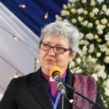 | 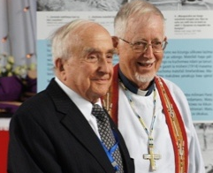

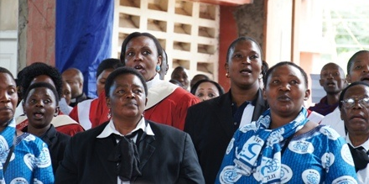 | 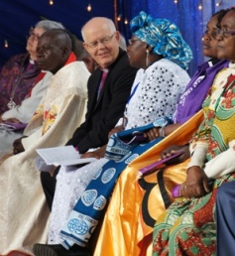 | 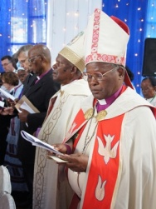 | 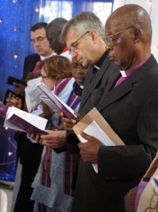 | 

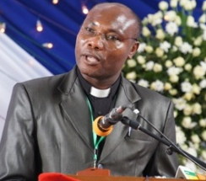 | 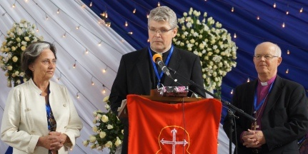 | 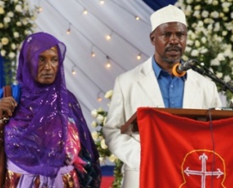 | 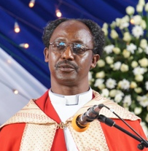 | 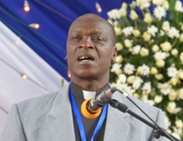

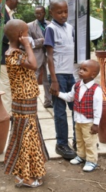 | 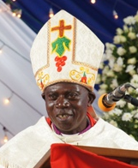 | 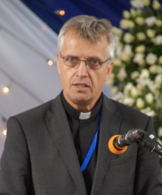 | 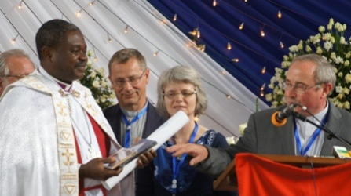 | 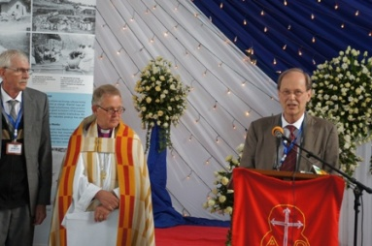

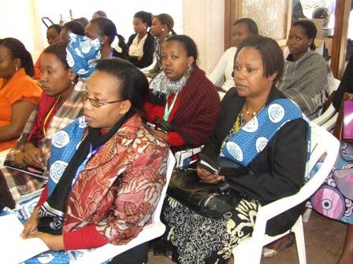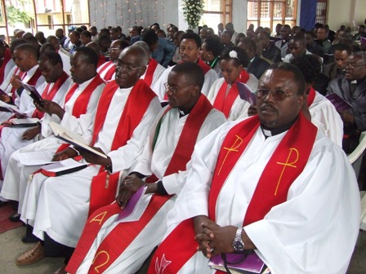

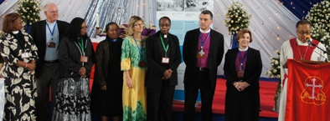 | 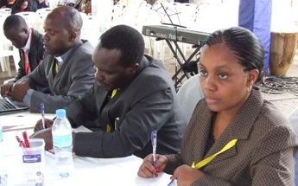 | 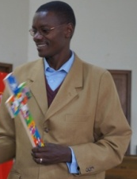

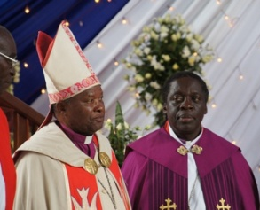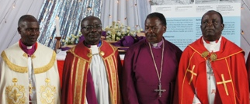 | 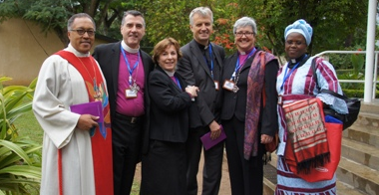
A Memorandum of Understanding was signed
Just after the service a brief ceremony on the signing of a Memorandum of Understanding for future cooperation between ELCT and ELCB took place.
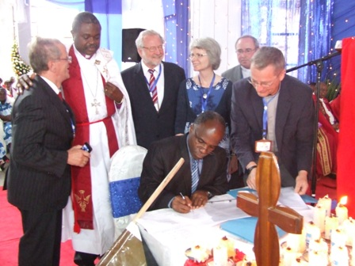  The Secretary General Mr Brighton Killewa signing the Memorandum on behalf of Evangelical Lutheran Church in Tanzania. | 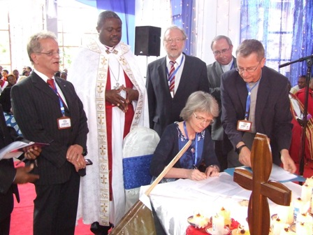  The President of ELCB Synod Mrs Dr Dorothea Deneke Stoll signing the Memorandum on behalf of Evangelical Lutheran Church in Bavaria.

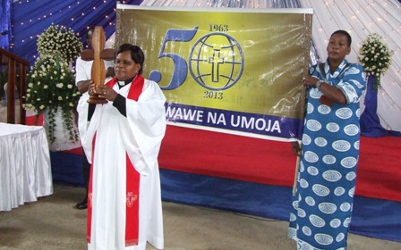
The theme of the ELCT jubilee was: ‘All may be one’, John 17: 21.
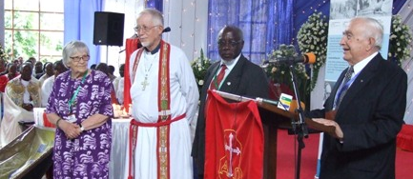
Those who were working for the Church in 1963. Standing from L to R Prof. Marja Liisa Swantz,
Rev. Herb Haffermann, Mr Johannsen Lutabingwa and Rev. Horst Becker.
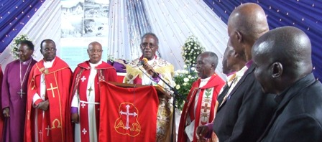
Some of the retired Bishops of ELCT at the Golden Jubilee celebration.

A special collection for flood victims
During the service the Presiding Bishop of ELCT announced a second collection for the flood victims in Germany whereby the Danube and Elbe Rivers had burst and flooded peoples’ houses. He said the collection was a sign of solidarity between Churches in Germany and the Lutheran Church in Tanzania.

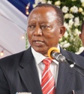  The former Tanzania Prime Minister, Hon. Frederick Sumaye represented the Government. | 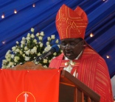  Bishop Dr Benson Bagonza,  ELCT Karagwe Diocese who led most part of the liturgy assisted by Bishop Charles Mjema. | 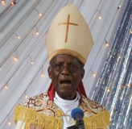  The former ELCT Presiding Bishop, Dr Samson Mushemba, delivering the sermon on June 23.

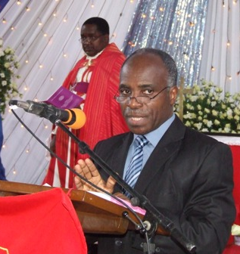  The ELCT Secretary General,  Mr Brighton Killewa. | 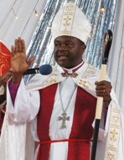  Bishop Malasusa when he dismissed worshippers after the Church Service. | 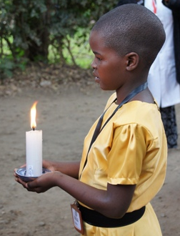  Children lit up 50 candles and handed them to some of the Church leaders.

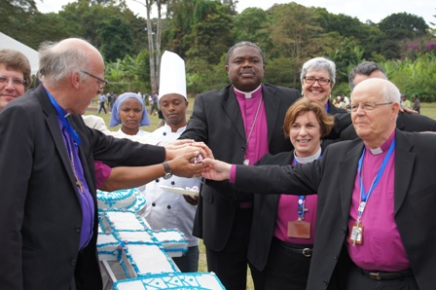
The day ended with an exchange of gifts and bishops from across the
globe cut a cake with an inscription: ‘All may be one’, John 17: 21.

Story by Elizabeth Lobulu of ELCT
Photo credit: © 2013 ELCT/ Michael Shayo (ELCT), Heidi Martinussen (LWF) & Antje Lanzendorf (Leipzig Mission).

